**Setting Up the Foundational Virtual Network Lab:**

**Overview**

I am currently undertaking the crucial first phase of creating a fully operational Virtual Network Lab. This is an essential, safe environment for practical cybersecurity training. This environment is built around VirtualBox, which is the software that manages my virtual machines (VMs). I have successfully laid the groundwork by installing three core systems: two Windows 8 and a Windows Server. My immediate focus is to transition these separate virtual computers into a single, cohesive network, much like wiring an actual office for the first time.

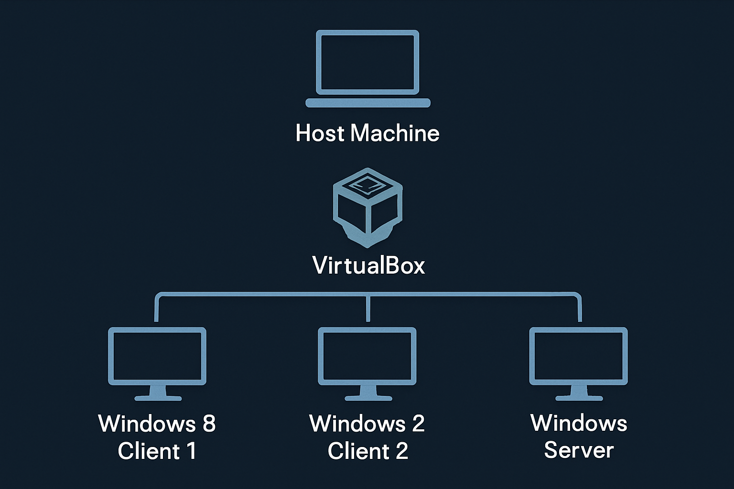

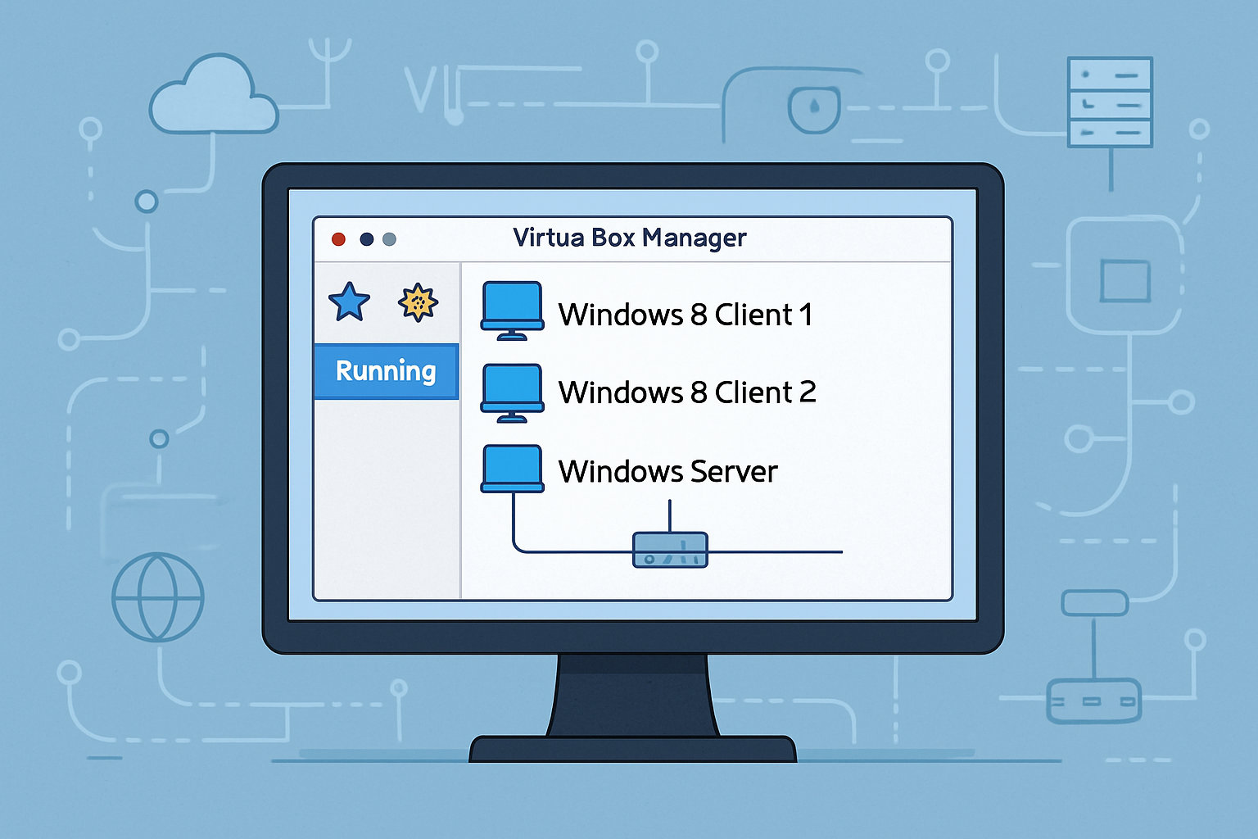

Let me walk you through how the downloads and installations were done;

**Phase 1**: **Selecting and Downloading the VirtualBox Platform Package**

The initial step involves navigating to the official VirtualBox download page

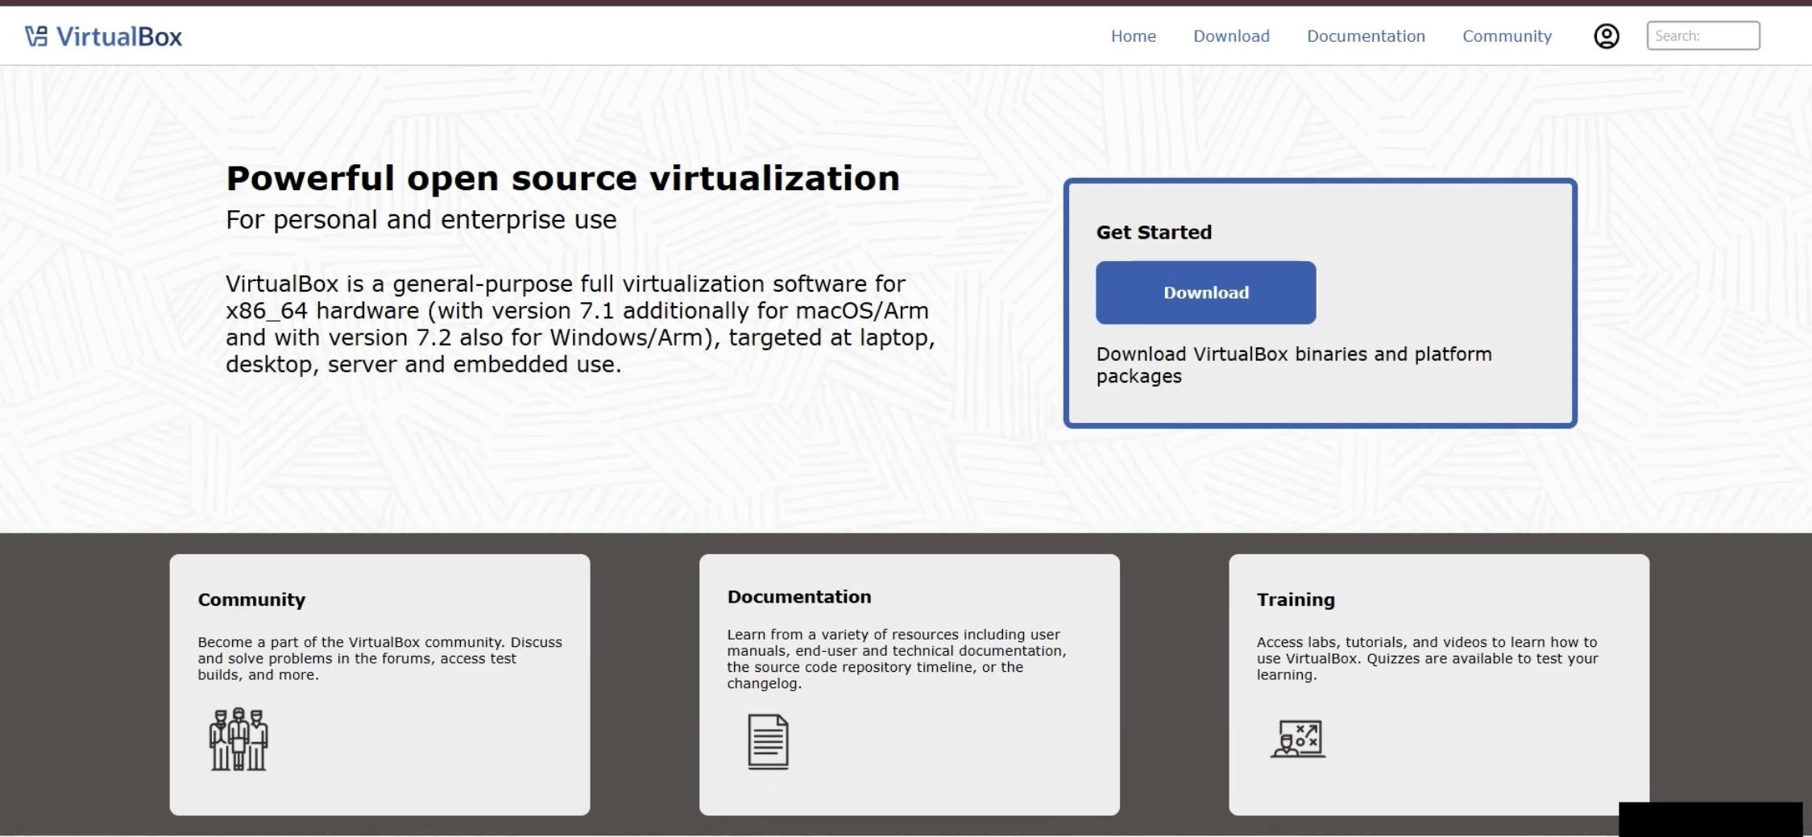

And scroll down the page to select the installer that matches my primary computer.

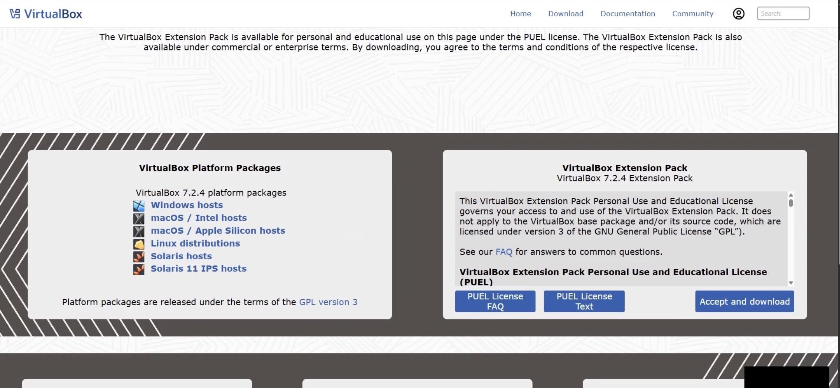

I correctly selected the Windows hosts link, which begins the download of the VirtualBox executable file (.exe). This package is the foundation for my entire virtual lab.

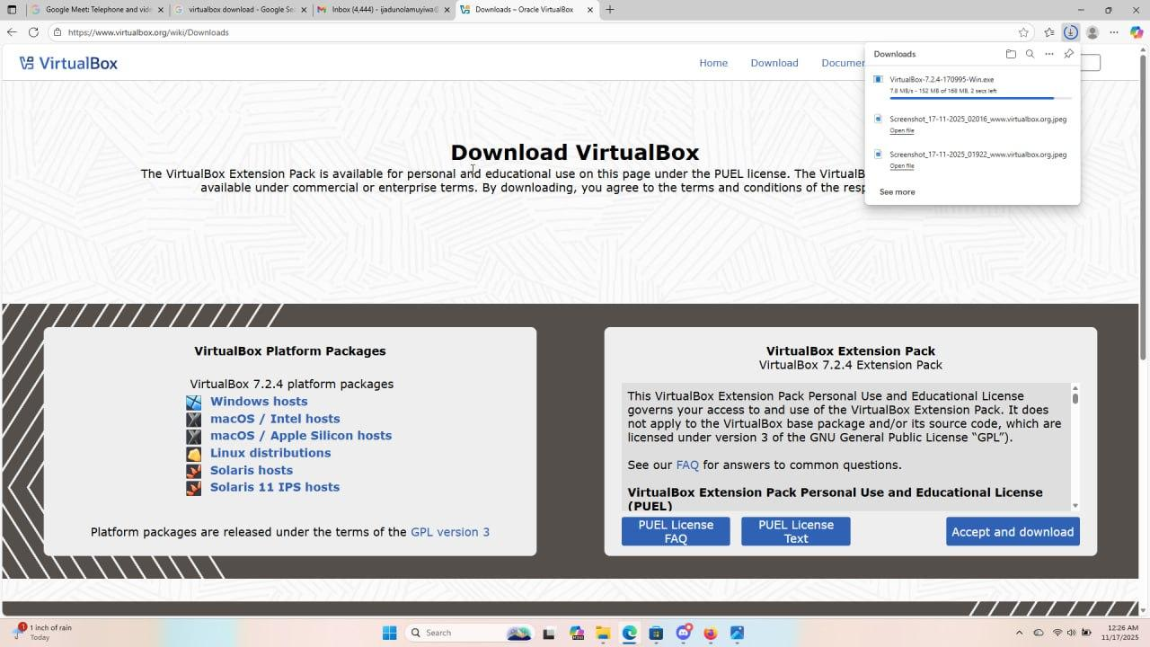

Once the download is complete,



I run the executable file to start the installation. And I got a page titled "Welcome to the Oracle VM VirtualBox Setup Wizard.

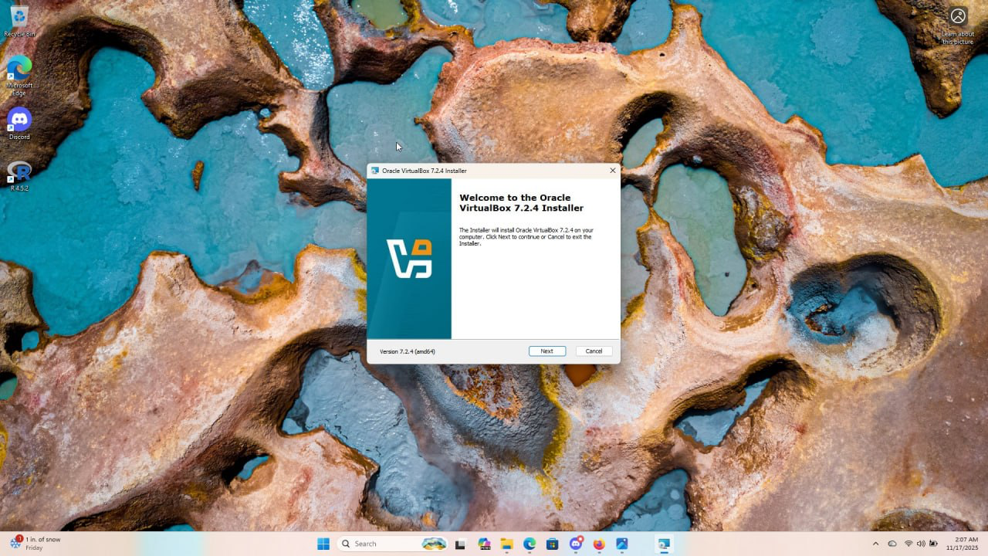

Then, I clicked next and I got the license agreement page.

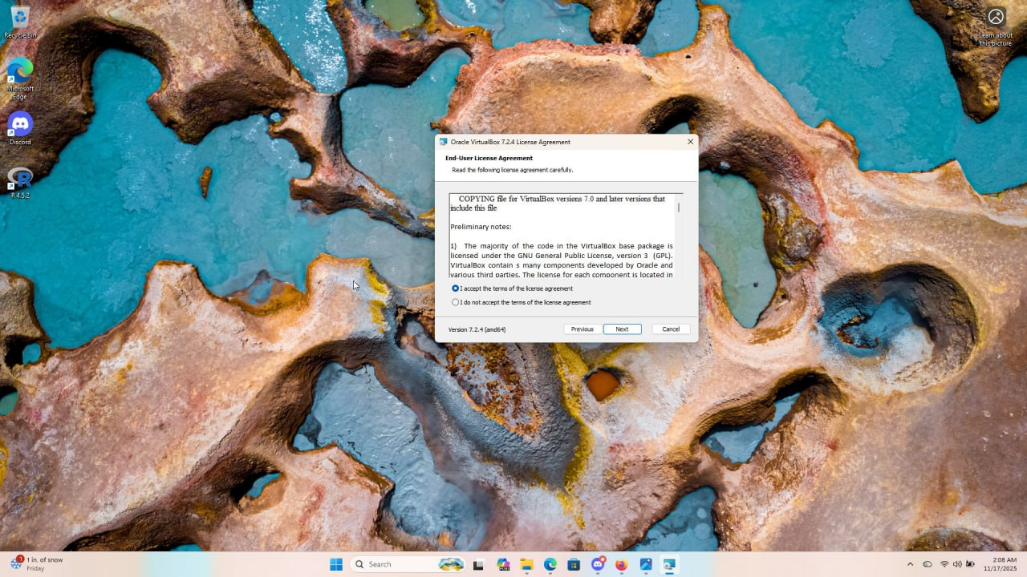

I agreed and I clicked next. I got to the next page where I can change the location which I didn't, I just clicked next.

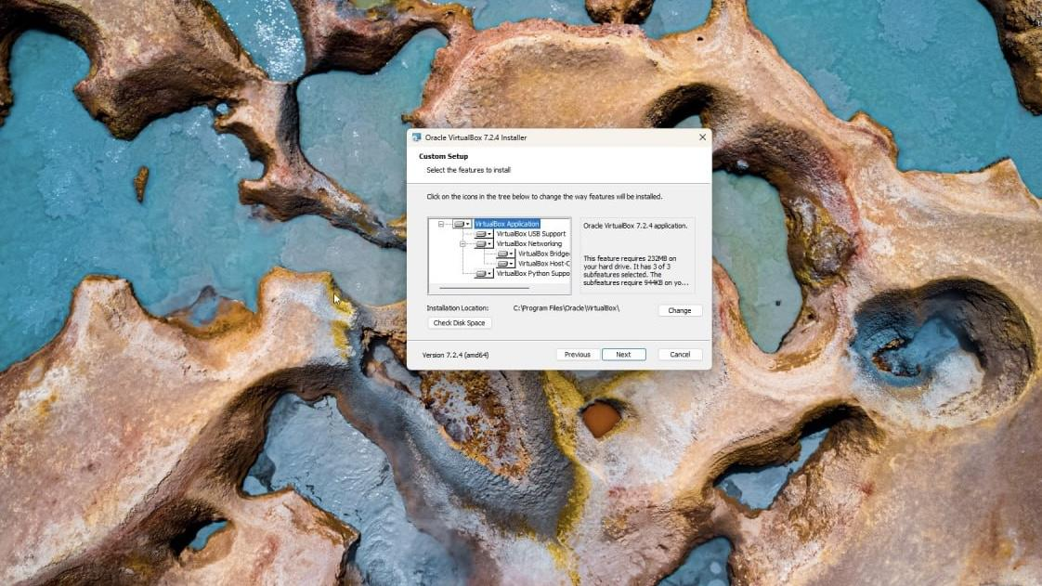

I got the warning page and after going through it, I clicked yes.

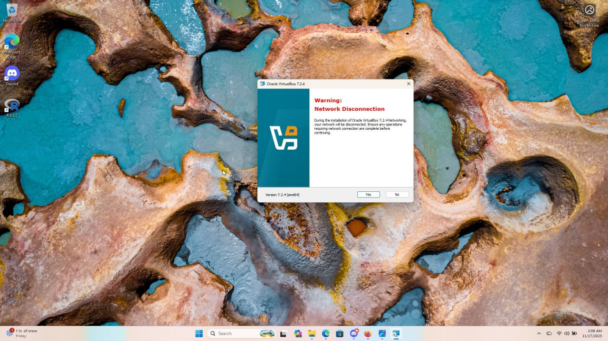

The next page opens and after reading I clicked yes so as to install the missing dependencies.

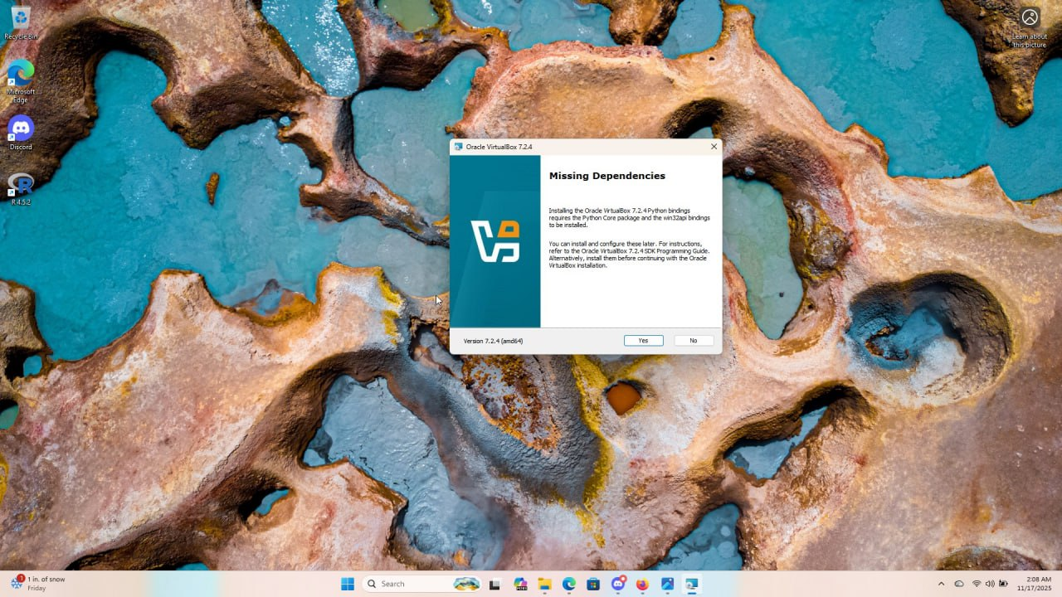

After the missing dependencies have been installed, the next step is to select the features to install. I selected all and clicked next

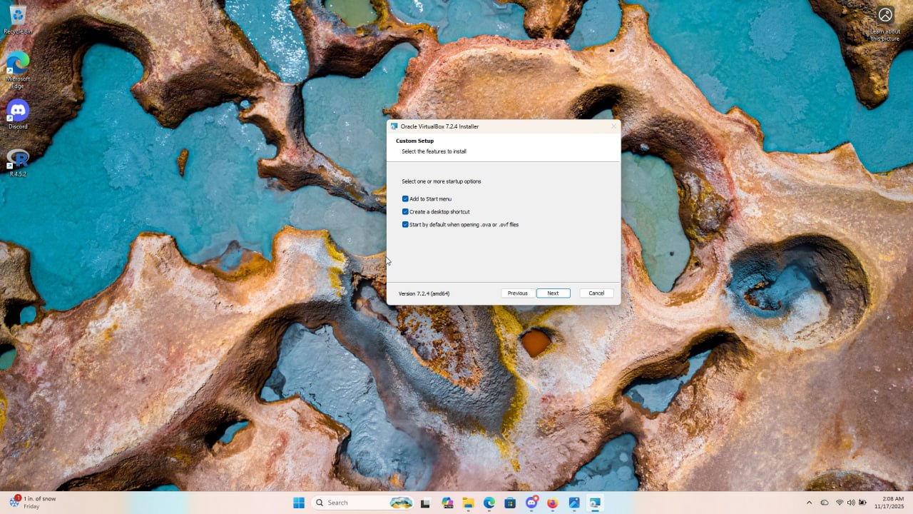

Then the next page was the install page and finally I clicked on the install page to start the installation.

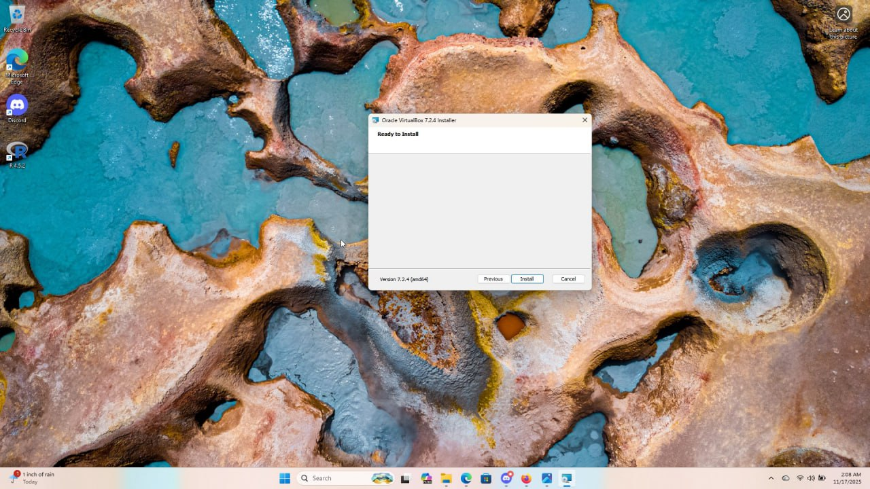

I clicked next and the installation began

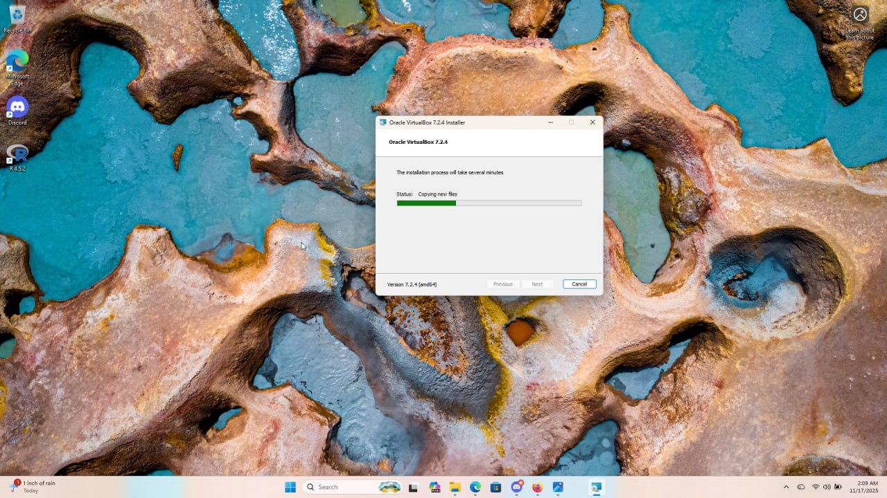

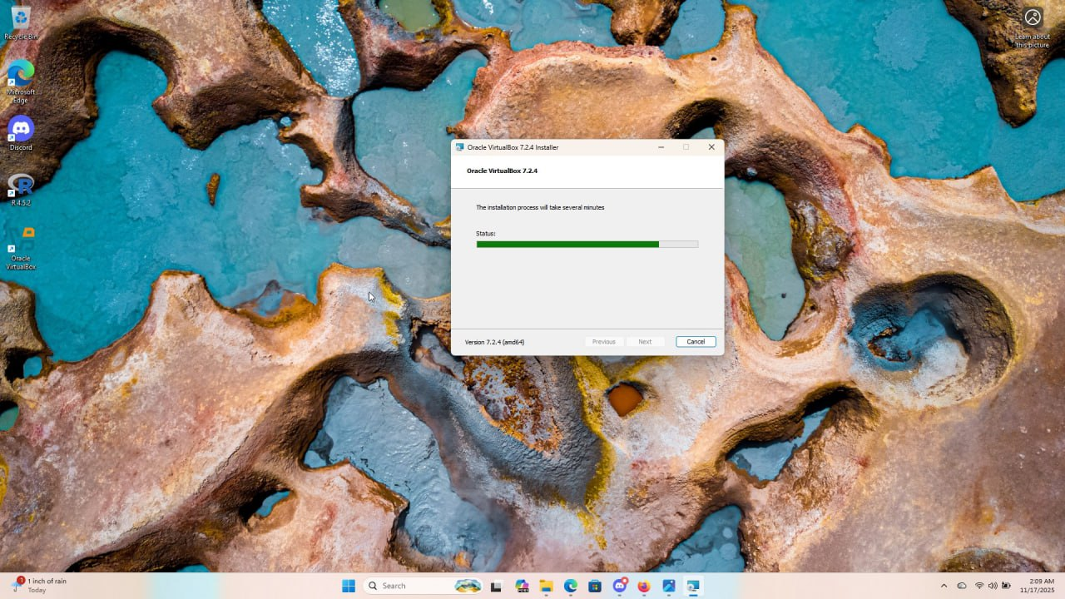

Then the installation of the VirtualBox was completed and I clicked finish.

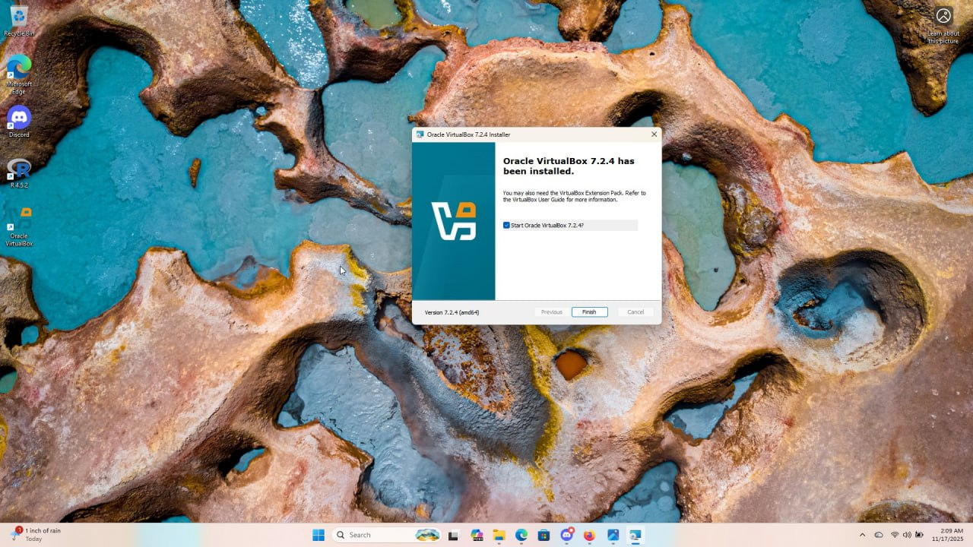

This is what I got when I open my virtual machine

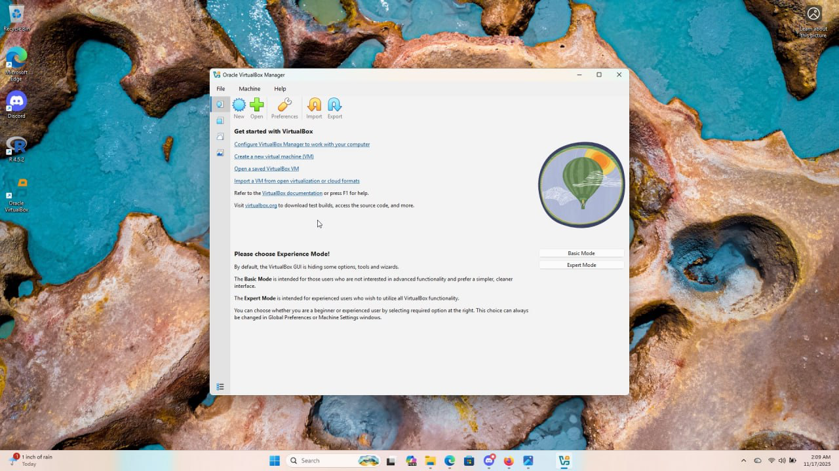

**Phase 2**: **downloading and installing the Windows Server on the VM**

Stage 1: I utilized Google Search to find the installation media for a modern, relevant operating system, selecting Windows Server 2022.

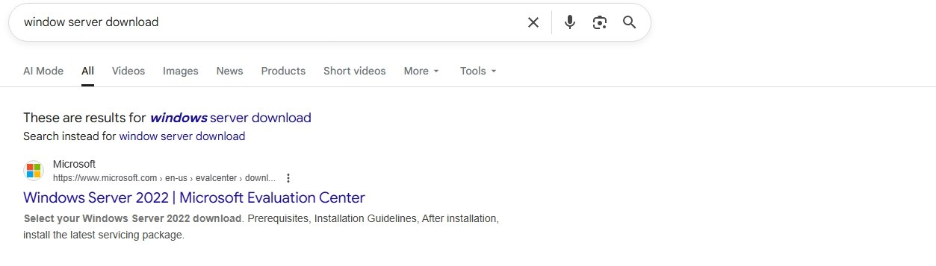

Upon reaching the download page,

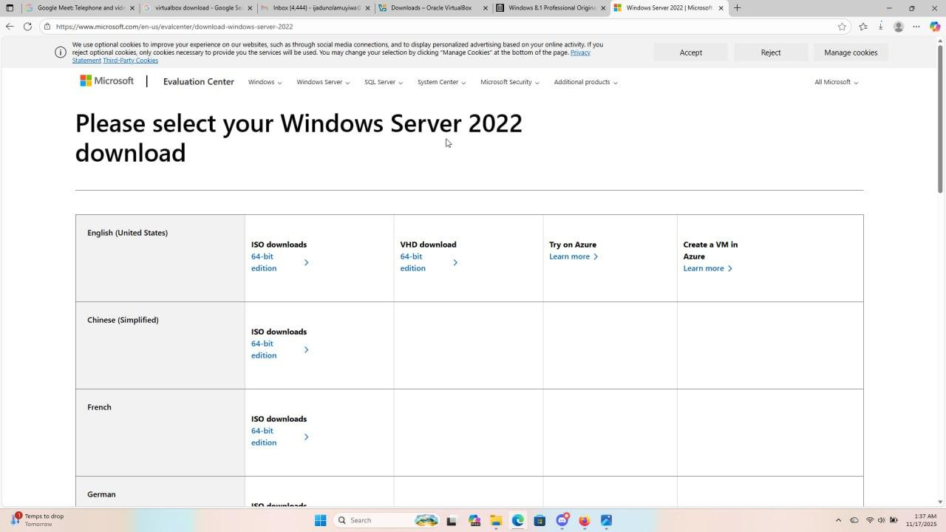

I selected the 64-bit edition.

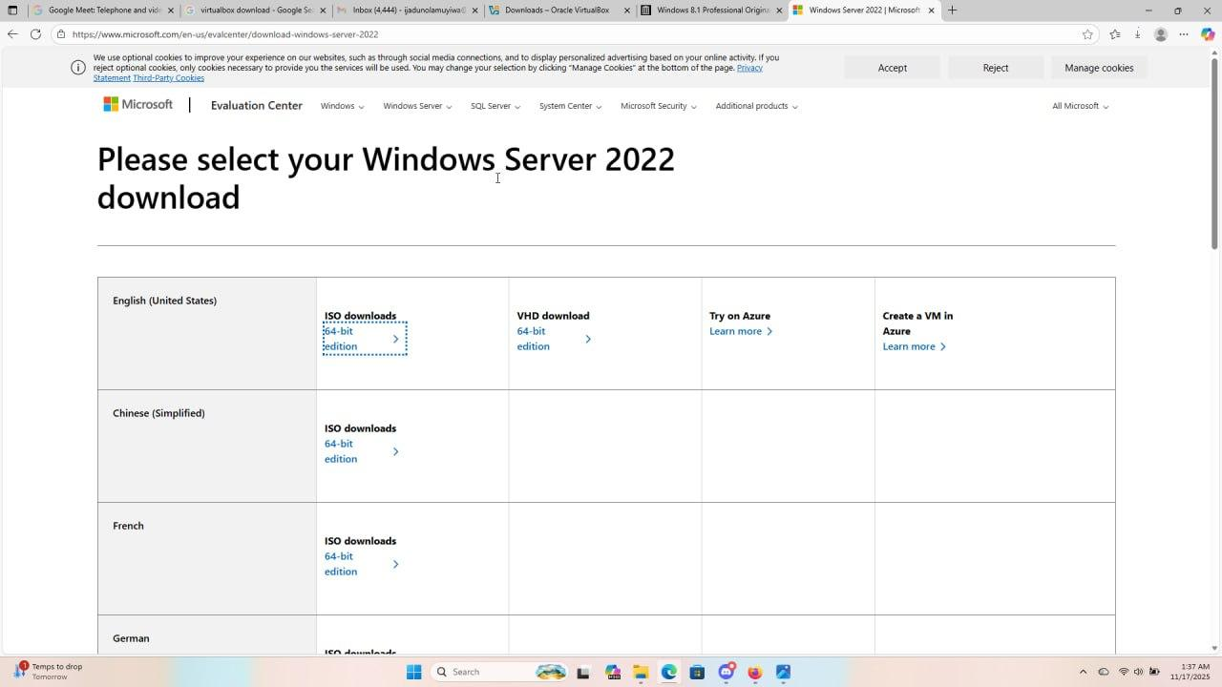

After confirming the selections, the download of the Windows Server 2022 image file (an ISO file) was initiated and completed.

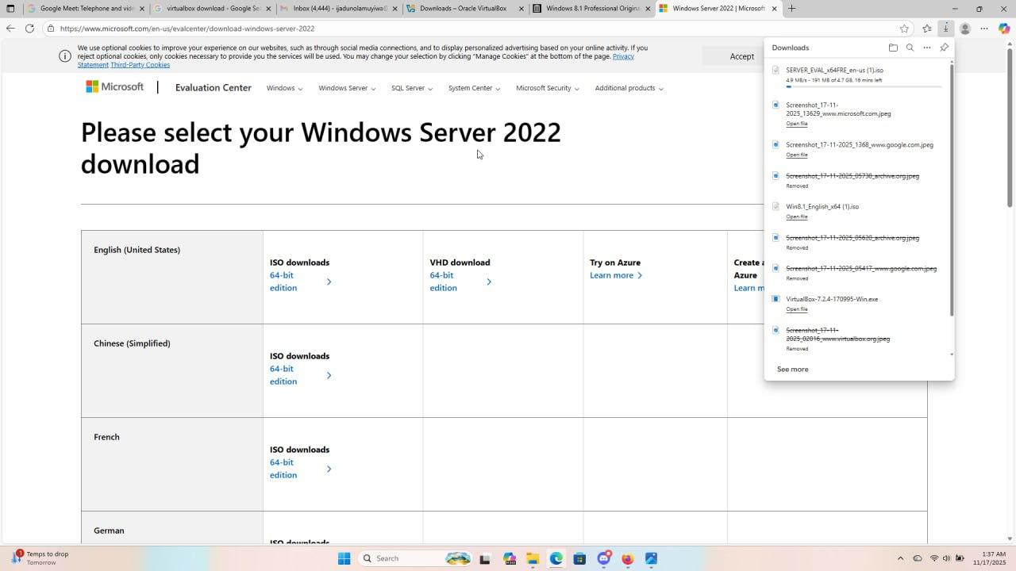

Stage 2: With the Server software now ready, the focus shifts back to the VirtualBox to begin creating the virtual computer itself. So inside the VirtualBox Manager, i clicked the "New" button. This action started the process of allocating virtual resources such as setting the amount of virtual RAM and hard disk space for the new Windows Server machine.

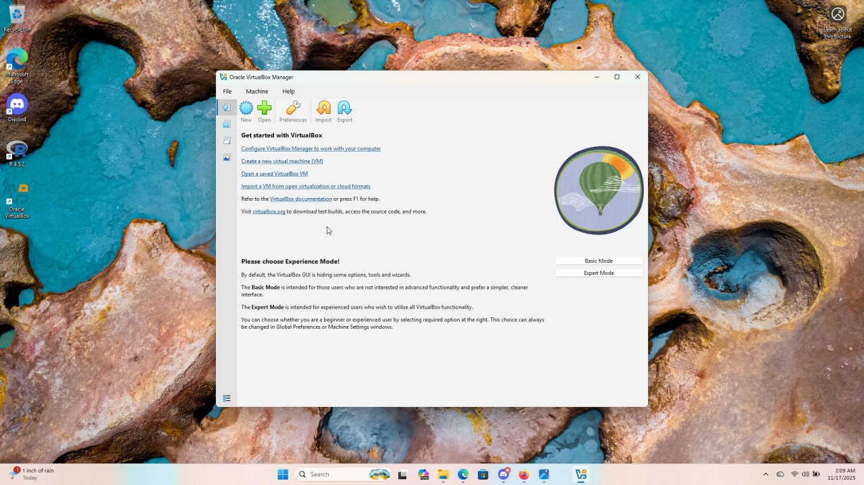

The final step in this stage was to mount the newly downloaded Windows Server 2022 file. To "mount" simply means connecting the downloaded ISO file (which acts like a virtual DVD) to the virtual machine I just created. This allows the new VM to "see" the operating system installer and begin the installation process when I turn it on.



After clicking the “new”, I have a page that involves dedicating specific virtual hardware resources to the new server.

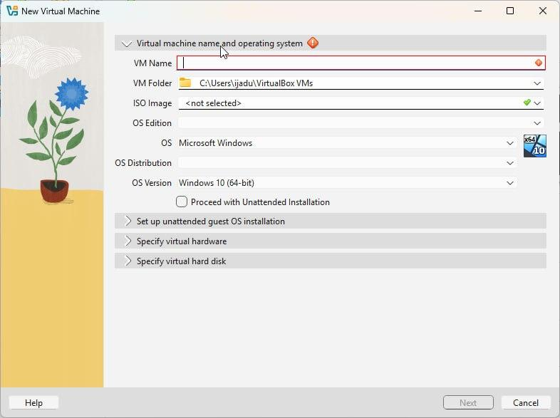

I began by giving my VM a logical Name which was “Windows Server new”, I clicked on the ISO Image and I successfully located the file called “SERVER_EVAL_x64FRE_en-us (1)” in the downloaded file, and uploaded it. I didn't thick the box to proceed with unattended installation.

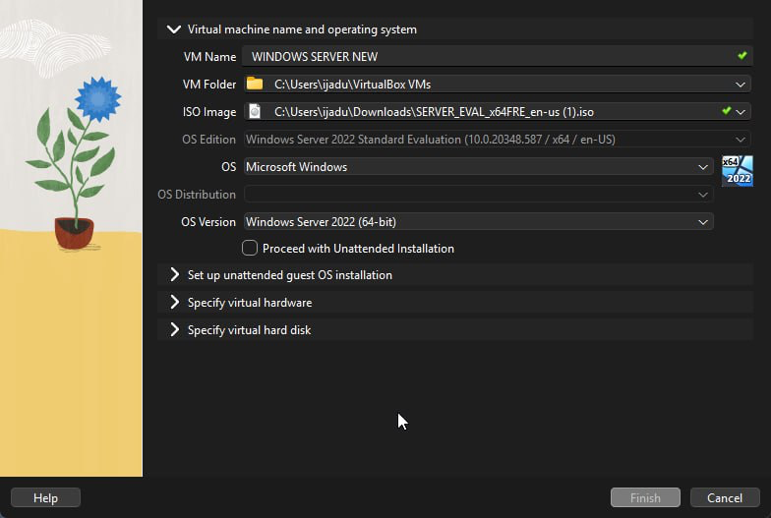

Next is configuration of the virtual hardware parameters, where I assigned 4096 GB (Gigabytes), for the Virtual Processors (CPUs), I assigned 4 processors, for the Virtual Hard Disk: I allocated 50 GB of virtual storage,

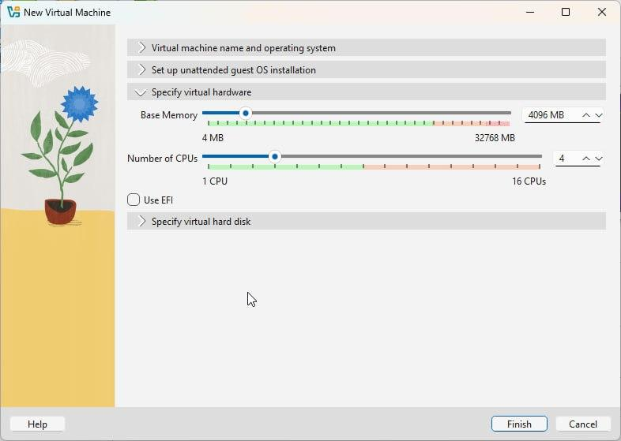

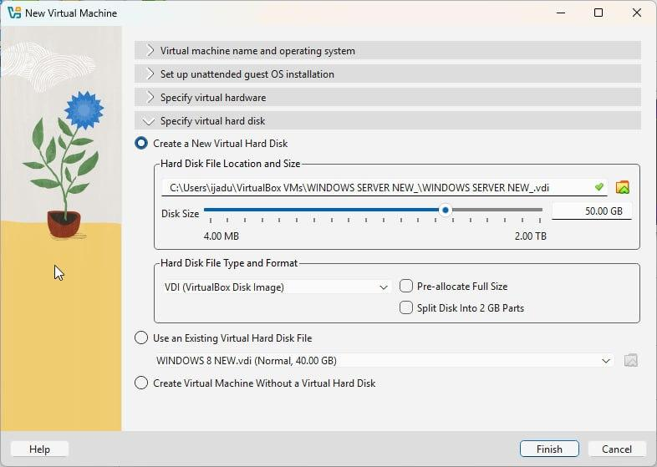

After Completion: By clicking "Finish," the definition of the Windows Server VM was complete, and the machine was ready to be powered on to begin the formal operating system installation.

**Phase 3: Downloading and installing the Windows 8 file on VMs**

This phase focuses on acquiring and configuring the standard client operating systems.

Stage 1: Downloading of Windows 8 file

I initiated a search to find the iso file for Windows 8.

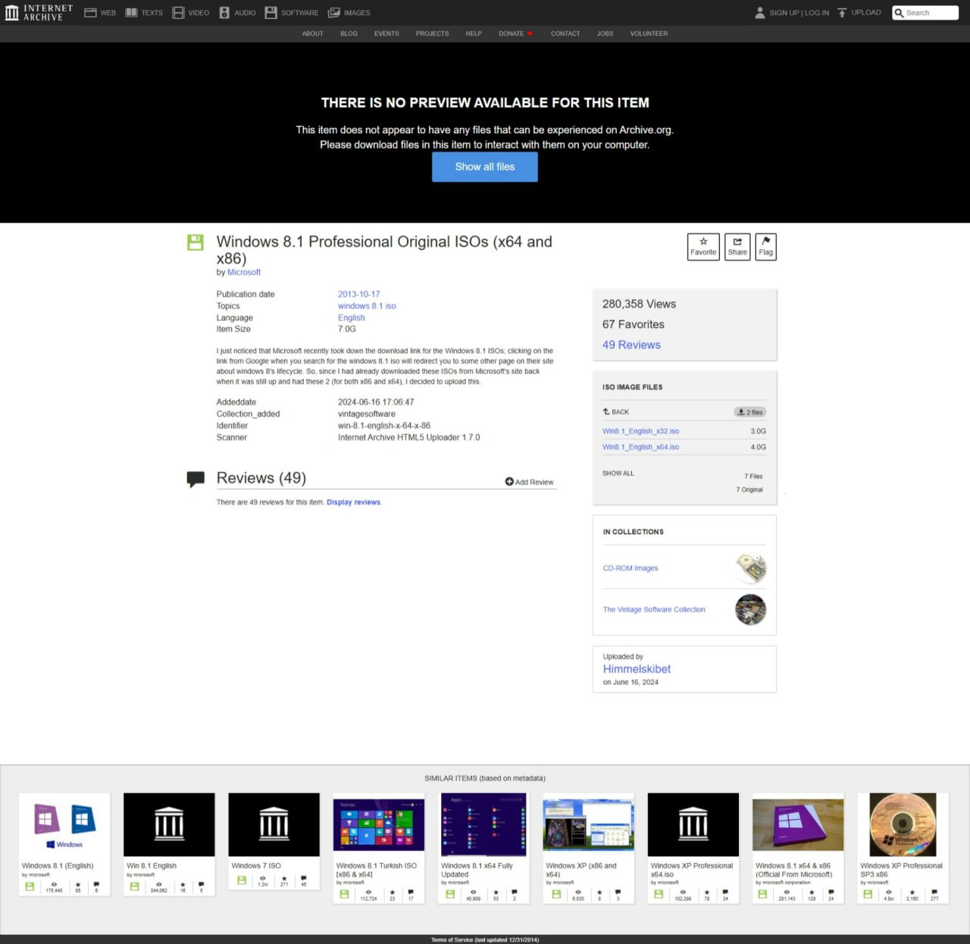

Upon locating the download source, i ensured the selection was the 64-bit edition. Then I clicked download

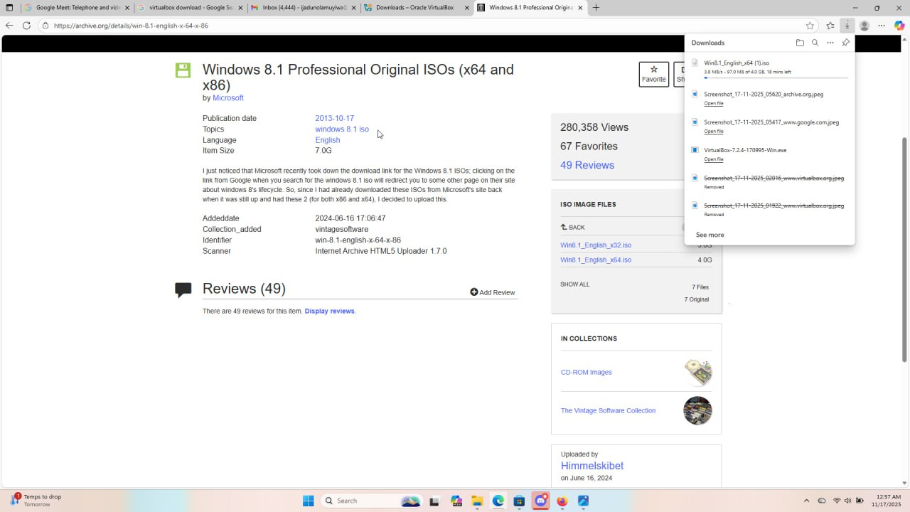

The process concluded with the successful download of the Windows 8 image file (the ISO file), making the software ready for use in VirtualBox.

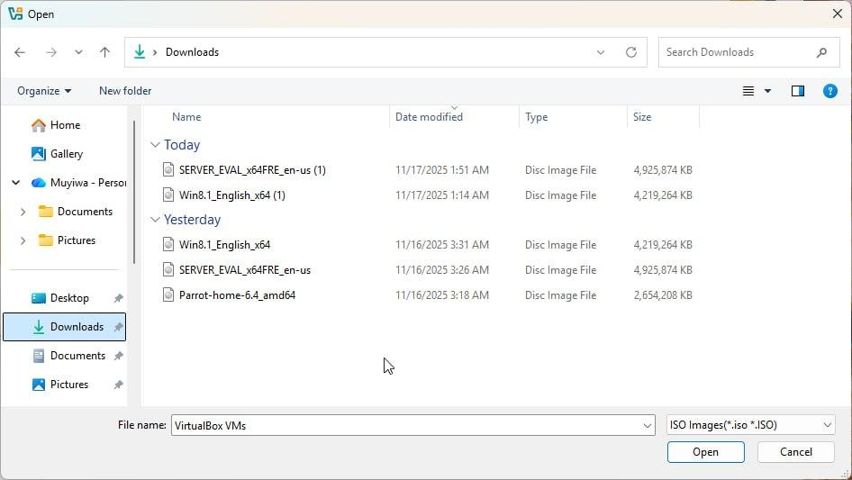

Stage 2: Creating and Configuring the Windows 8 VM

With the Windows 8 software ready, you returned to the VirtualBox Manager to define the machine that will run it. This process was then repeated for the second Windows 8 VM.

I clicked "New" in VirtualBox and initiated the setup process for the first window 8



I assigned a virtual Name for the first client to be “Windows 8 New”

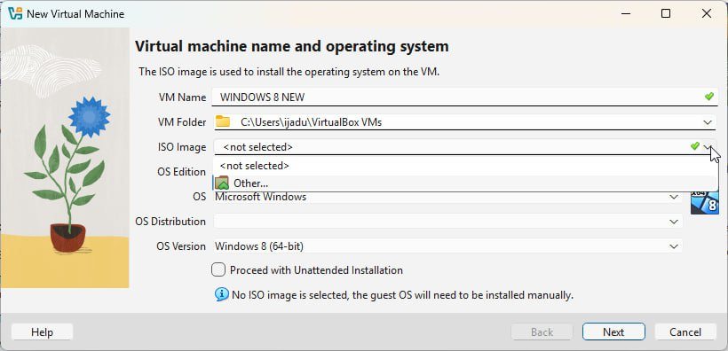

and successfully mounted (connected) the downloaded Windows 8 ISO file to the new virtual machine.

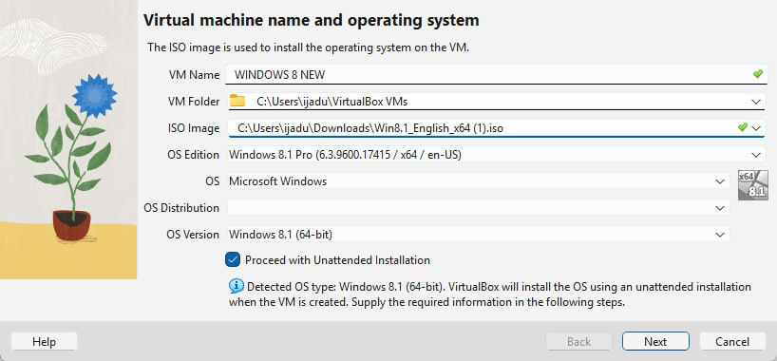

I correctly chose to Skip Unattended Installation to maintain full control over the setup.

I defined the robust virtual hardware settings for the client VM to ensure smooth operation.i allocated 2 GB of RAM and 4 processors.And for the virtual hard disk, I allocated 40 GB of virtual storage space.

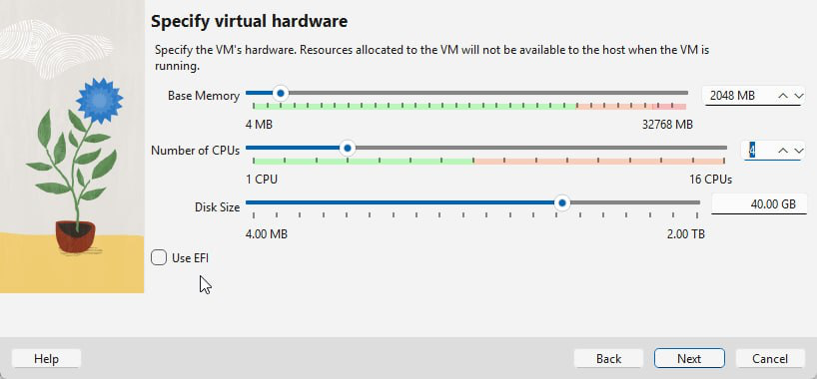

By clicking “Next” and then "Finish," the configuration for the first Windows 8 VM was saved.

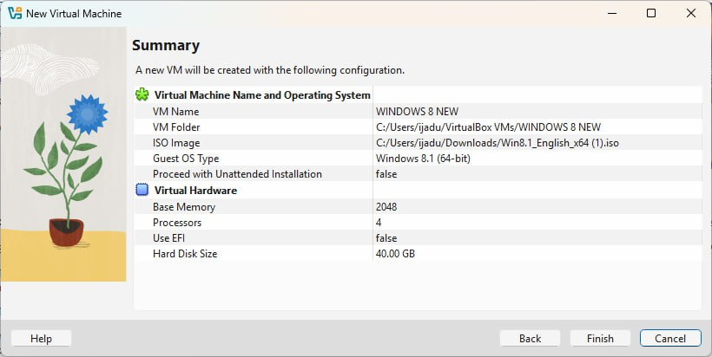

I Repeated the whole process for “Windows 8 New 2 “ . I have now documented the successful acquisition and provisioning of all four virtual machines, the Windows Server and both Windows 8 clients.